**Practical No. 5**

1. **Design a Program for creating machine that accepts**

**the string always ending with 101.**

1. **Accepting String**

**Code:**

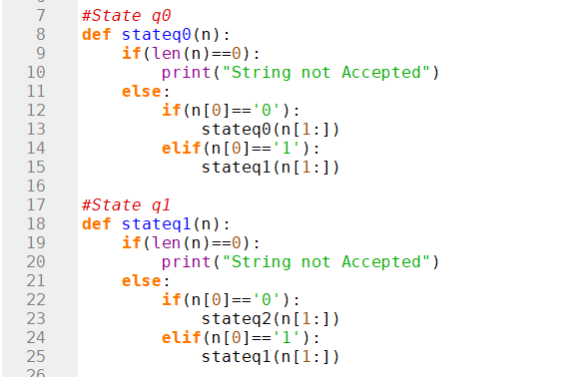

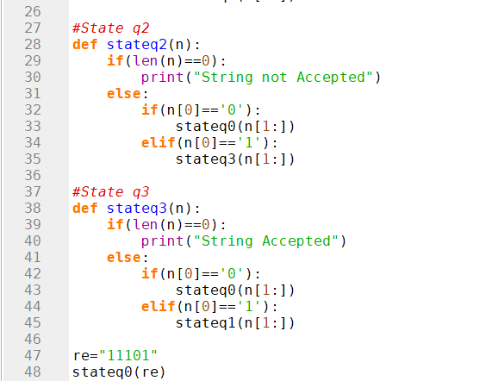

**Output:**

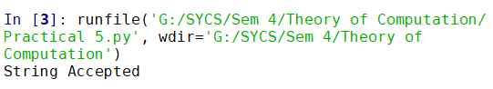

1. **Not Accepting String**

**Code:**



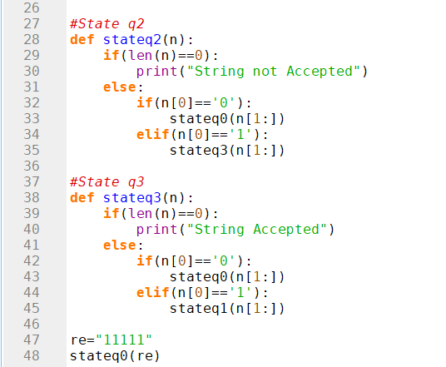

**Output:**

